BALTIMORE COUNTY PUBLIC SCHOOLS
Dr. Darryl L. Williams Superintendent 6901 North Charles Street Towson, MD 21204

August 2020

Dear Parent/Guardian,

Your child may be eligible to receive exam fee reductions, additional college application fee waivers and other benefits if they:
- are eligible and/or receive Free and Reduced Priced Meal (FARMs) benefits under the National School Lunch Program,
- are a part of a family with a total income at or below 185% of the poverty level issued annually by the U.S. Department of Health and Human Services,
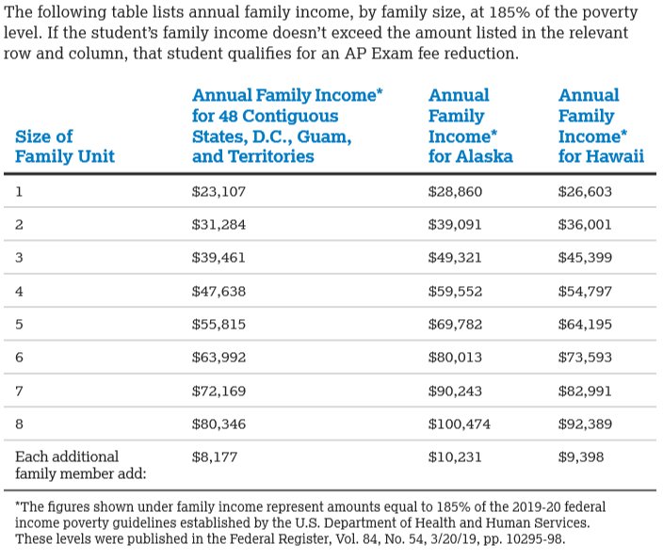
- are directly certified without application for free school meals because they are:
  - in foster care or Head Start, or
  - homeless or migrant, or
  - living in households that receive SNAP/Food Stamps, TANF cash assistance, or the Food Distribution on Indian Reservations benefits
- the student is enrolled in a federal, state, or local program that aids students from low-income families (e.g., Federal TRIO programs such as Upward Bound & AVID).
- the student’s family receives public assistance.
- the student lives in federally subsidized public housing or a foster home or is homeless.
- the student is a ward of the state or an orphan.

By signing below, I confirm that my child is eligible to receive exam fee reductions and additional college application fee waivers based on at least one of the criteria above. I give BCPS permission to share information from my Household Meal Benefit Application with my child’s (ren’s) school counselor, test coordinator(s), the College Board, and directly to colleges, universities and other educational institutions during the application process.

____________________________________ _____________________________________
Parent/Guardian’s Name (please print) Parent/Guardian’s Signature

_________________________________________________ _____________________________________
Student’s Name (please print) School

____________________________________ ______________________________________
Student’s ID Number Date

***Please return this signed form to Mrs. Pearlstein, School Counseling Secretary, epearlstein@bcps.org on or before September 30, 2020 ***

